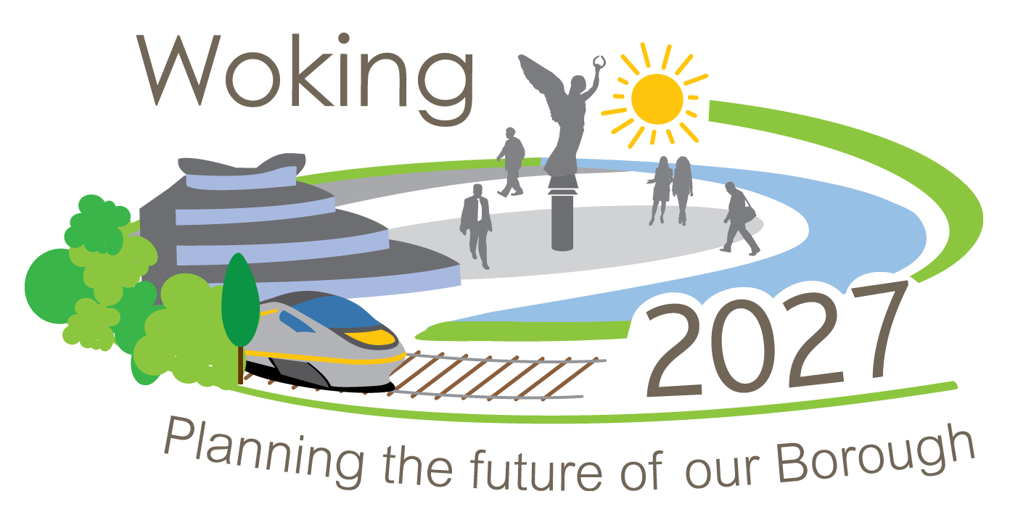

Woking Borough Council
Local Development Framework

Community Infrastructure Levy – Charging Schedule

Strategic Environmental Assessment
SCREENING STATEMENT

Determination under Regulation 9 of the SEA Regulations 2004



December 2012

Consultation procedure

This Draft Screening Statement had been issued the following statutory bodies for their comments:
- The Environment Agency,
- Natural England, and
- English Heritage.
- Introduction

  - This statement outlines the Council’s determination under Regulation 9 (1) of The Environmental Assessment of Plans and Programmes Regulations 2004 on whether a Strategic Environmental Assessment (SEA) is required, for a Community Infrastructure Levy (CIL) Charging Schedule.

  - The requirement for SEA is assessed in accordance with Regulation 9 (1) of the Environmental Assessment of Plans and Programmes Regulations 2004).

- Strategic Environmental Assessment

  - Under the requirements of European Union Directive 2001/42/EC (Strategic Environmental Assessment (SEA) Directive)) and the Environmental Assessment of Plans and Programmes Regulations (2004), specific types of plans that set the framework for the future development consent of projects must be subject to an environmental assessment.

  - There are exceptions to this requirement for plans that determine the use of a small area at a local level and for minor modifications if it has been determined that the plan is unlikely to have significant environmental effects.

  - In accordance with the provisions of the SEA Directive and the Environmental Assessment of Plans and Programmes Regulations (2004) (Regulation 9 (1)), the Council must determine if a plan requires an environmental assessment.

- Sustainability Appraisal

  - Under separate legislation (the Planning and Compulsory Purchase Act 2004 and associated Regulations), the Council is required to carry out a Sustainability Appraisal (SA) for all Development Plan Documents. This considers the social and economic impacts of a plan as well as the environmental impacts.

  - In accordance with current Regulations (Town & Country Planning (Local Planning) (England) Regulations 2012) a SA is required for Development Plan Documents (DPD) but not other lower level documents. Accordingly an SA is not required for a CIL charging schedule. It should be emphasised that a comprehensive SA of the Core Strategy had been carried out and scrutinised at an Independent Examination. The Inspector was satisfied that it was sufficiently robust and comprehensive to in assessing the economic, social and environmental implications of the Core Strategy. The commitment to adopt CIL is clearly set out in the Core Strategy, which is now adopted.

- The SEA Screening Process

  - The process for determining whether or not an SEA is required is called screening. In order to screen, it is necessary to determine if a plan will have significant environmental effects using the criteria set out in Annex II of the Directive and Schedule I of the Regulations. A determination cannot be made until the three statutory consultation bodies have been consulted: The Environment Agency, Natural England and English Heritage.

  - Within 28 days of making its determination the authority must publish a statement, such as this one, setting out its decision. If it determines that an SEA is not required, the statement must include the reasons for this.

- Background to the Community Infrastructure Levy

  - The ability of Local Authorities to secure payments from development to provide infrastructure needed to support growth is currently by planning obligations under Section 106 of the Town & Country Planning Act 1990.

  - The Community Infrastructure Levy (CIL) Regulations came into force on 6th April 2010 and set out how and when payments for infrastructure projects will be collected from developments in the future. The CIL Regulations make provision for adoption of a local CIL charging schedule which is used to determine payments, based on gross internal floorspace after deducting any floorspace lost to demolition. However should a CIL charging schedule not be adopted by April 2014, then under the CIL Regulations the Borough Council's ability to seek S106 payments for infrastructure is considerably reduced.

  - The CIL Regulations make provision for differential charging rates across local authority areas and rates that vary according to land use and location is likely to be the case in Woking Borough with a CIL charging schedule giving borough wide coverage. Any variations in rates must be based solely on viability and cannot be used as a policy tool.

  - The Borough Council plans to adopt a CIL charging schedule no later than April 2014 which will be used to collect levy payments from developments to part fund a range of infrastructure projects that are needed to support growth in the borough.

- Draft SEA Screening

  - This Draft Screening Statement sets out the Council’s determination under Regulation 9 (1) of the Environmental Assessment of Plans and Programmes Regulations 2004 on whether or not a SEA is required for a CIL charging schedule. The statutory bodies have been consulted.

  - Appendix 1 sets out the process for determining if CIL charging schedule will have significant environmental effects using the criteria set out in Annex II of the Directive and Schedule I of the Regulations.

  - In accordance with current Regulations (Town & Country Planning (Local Planning) (England) Regulations 2012) an SA is required for Development Plan Documents (DPD) but not other lower level documents. On the basis of the Screening process it is the Council’s opinion that the CIL charging schedule does not require an SEA or SA under the SEA Directive and Environmental Assessment of Plans and Programmes Regulations (2004).

Appendix 1 – Draft SEA Screening for CIL

Criteria (Annex II of SEA Directive and Schedule I of Regulations) | Woking Borough Council response
Characteristics of the plan or programme
(a) The degree to which the plan or programme sets a framework for projects and other activities, either with regard to the location, nature, size and operating conditions or by allocating resources. | The framework is set by national regulations on the use of charging schedules in the Community Infrastructure Levy Regulations 2010 (as amended). The charging schedule itself does not set the framework for future consents as this is the remit of higher level plans and individual projects.
(b) The degree to which the plan or programme influences other plans and programmes including those in a hierarchy. | The charging schedule is a financial tool to be applied to individual project consents. The charge is set outside of the plan making process and does not influence the content of plans or programmes.
(c) The relevance of the plan or programme for the integration of environmental considerations, in particular with a view to promoting sustainable development. | A CIL charge can be used to raise monies from individual development projects towards infrastructure which can aid the delivery of sustainable development. However, the charging schedule is not a plan or programme but a financial tool.
(d) Environmental problems relevant to the plan or programme. | A charging schedule does not and cannot set policy guidance or interventions to deal with environmental problems. The charging schedule is only a tool by which to raise contributions from individual development projects, although monies raised can be spent on alleviating environmental problems if considered to be infrastructure.
(e) The relevance of the plan or programme for the implementation of Community (EU) legislation on the environment (for example, plans and programmes linked to waste management or water protection). | None.
Characteristics of the effects and of the area likely to be affected
(a) The probability, duration, frequency and reversibility of the effects. | A CIL charging schedule will not in itself set out, guide or bring forward development plans or projects. It will purely set out a charge which applies to individual consents. As such there is no mechanism for effects to arise from the charge itself, although individual infrastructure projects on which CIL monies will be spent could have an impact. However, such infrastructure projects are likely to be subject to environmental appraisal either as part of the plan making process or within individual consents.
(b) The cumulative nature of the effects | A CIL charge could be spent on a range of infrastructure projects, but does not in itself give consent for such projects or is a material consideration in the decision making process. As such, no cumulative effects arise from the charge itself, but as in (a) above, individual infrastructure projects on which CIL monies will be spent may have an effect.
(c) The transboundary nature of the effects. | Given the nature of CIL, it is considered that no transboundary effects will arise
(d) The risks to human health or the environment (for example, due to accidents) | None
(e) The magnitude and spatial extent of  the effects (geographical area and size  of the population likely to be affected) | Although differential charges can be set for different areas of the Borough (and different types of development) a CIL charging schedule is likely to have borough wide coverage in some form or another. This will affect all planning applications for qualifying development across the borough, but only in terms of a charge raised not whether the project is acceptable in planning terms or not.
(f) The value and vulnerability of the area likely to be affected due to:  i) Special natural characteristics or cultural heritage;  ii) Exceeded environmental quality standards or limit values;  iii) Intensive land-use. | Given the nature of the document: -  i) None  ii) None  iii) None
(g) The effects on areas or landscapes  which have recognised national, Community or international protection status. | Avoidance of impacts to the Thames Basin Heaths SPA is dealt with in other guidance documents produced by the Borough Council. Whilst the CIL charge (at present) can be used to avoid impacts to Natura 2000 sites by providing monies towards infrastructure which off-sets recreational impacts, the charging schedule itself is only a financial tool by which to raise monies. It does not set the policy framework for individual project consents or the framework for avoiding infrastructure.

